**Batch: A – 3 (H3 -2)**

**Roll No.: 16014022050**

**Experiment: 05**

|  |
| --- |
| **Title: Working with time-series data.** |



# Objective:

# *Search/locate and download the time series Data*

# *To learn how to visualize time series data*

# *Applying trend line over visualized time series data using analytics options*

# *Perform forecast over the time series using analytics options*



# Course Outcome:

# CO1: Learn how to locate and download datasets, extract insights from that data and present their findings in a variety of different formats.

# CO3: Apply data visualization best practices.

# Books/ Journals/ Websites referred:

# None.

# Resources used:

<https://www.kaggle.com/datasets/abeperez/historical-plane-crash-data?select=Plane+Crashes.xlsx>

Tableau Software

# Theory:

# Definition Time series:

Time series forecasting is a crucial need for many organizations as it enables them to examine various dimensions of data over time, identify trends, and detect seasonal patterns. Time series analysis, a statistical technique, involves recording and analyzing data points over specific time intervals, such as daily, monthly, or yearly periods. A time series chart visually represents this data across the chosen time interval. This analytical approach finds applications in various fields, including stock market analysis, tracking population trends through census data, or studying sales and profit trends.

Time series analysis assists organizations in uncovering the root causes of trends and consistent patterns over time. By employing data visualizations, business users can easily discern seasonal trends and delve into the reasons behind these patterns. Modern analytics platforms offer more sophisticated visualizations than traditional line graphs.

In a time, series, quantitative data points are arranged chronologically, resulting in a statistical series. There are four key components in a time series:

1. **Secular trend:** This component describes the long-term movement or overall trend in the data.
2. **Seasonal variations:** These variations represent recurring patterns that occur at specific times within a year.
3. **Cyclical fluctuations:** Cyclical variations are periodic but not tied to a particular season.
4. **Irregular variations**: These are unpredictable and non-random sources of variation in the series.

The additive model represents a specific observation in a time series as the sum of these four components. In contrast, the multiplicative model represents it as the product of these components, emphasizing their interrelationships.

# Following points should be written by students:

# Observation after plotting of time series data.

# Observation after plotting trend line (Linear, Exponential and polynomial).

# Observation after Forecast (Automatic, Additive, and multiplicative, along with season options).

# Note: Detail observation needed along screenshots wherever required

* **Plotting Time Series Data:**

The line graph of the time series data below displays the number of passengers fatalities over several years, offering insights into the same.

# 

# Linear Trend Line:

Adding a trendline to the line graph demonstrates a consistent, long-term increase in fatalities in airplane crashes over the years.

# 

* **Exponential Trend Line:**

Adding an exponential trend line indicates that over time, there has been an exponential increase in passenger fatalities in airplane crashes. The overall trend shows a concerning rise in fatalities overall.

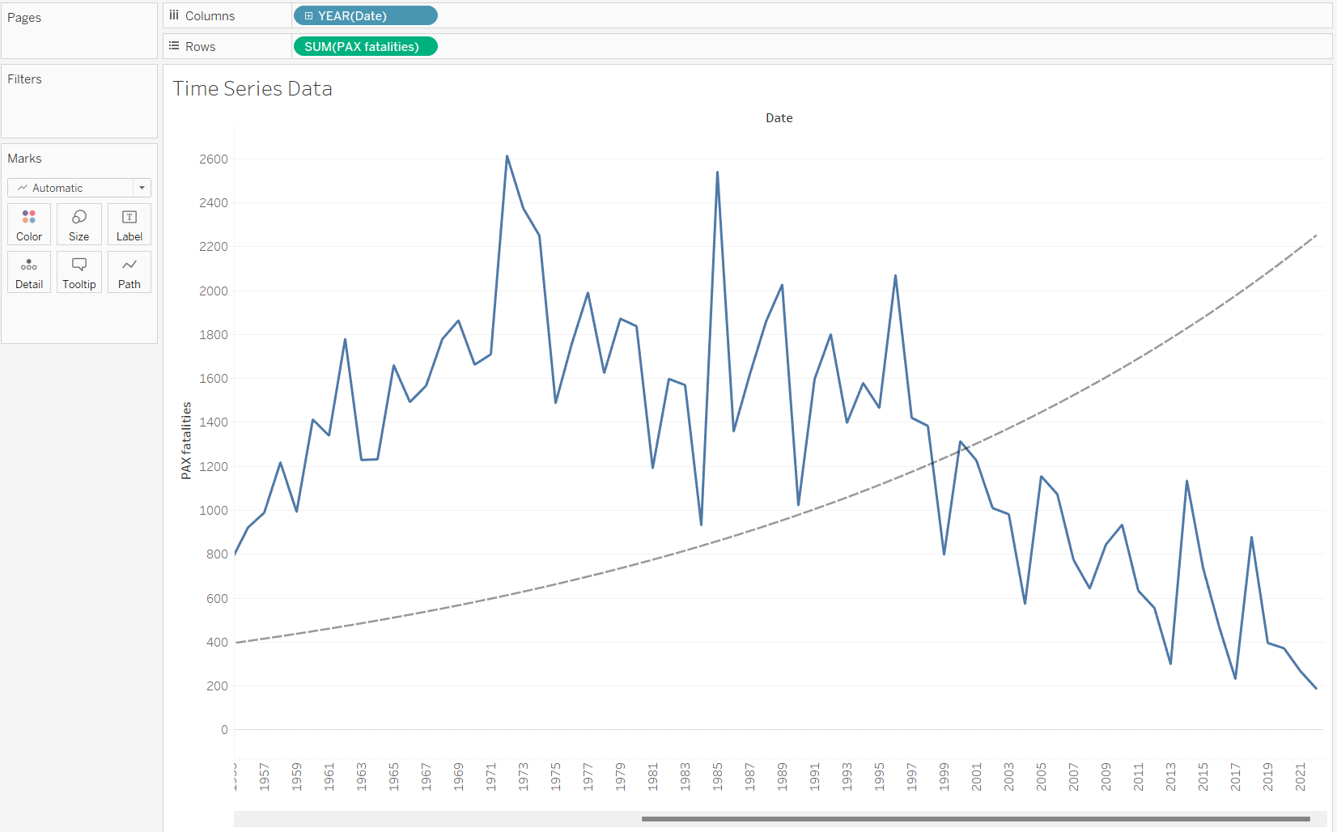

* **Polynomial Trend Line:**

The polynomial trend line indicates a more complex and non-linear trend in passenger fatalities over the years. Unlike a simple linear or exponential trend, a polynomial trend suggests that the relationship between time and fatalities is characterized by fluctuations and variations.

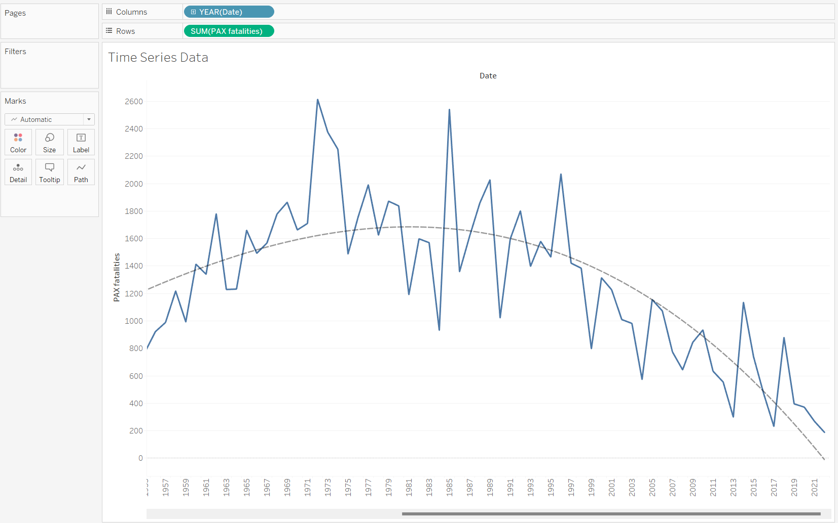

# Automatic Forecast:

# Transitioning to a new database because my original database isn’t forecasting properly. Automatic forecasting of order date discounts involves using data analysis and predictive algorithms to estimate future discount trends based on historical order date discount data. Forecasting indicates that the amount of discount they provide increases slowly annually.

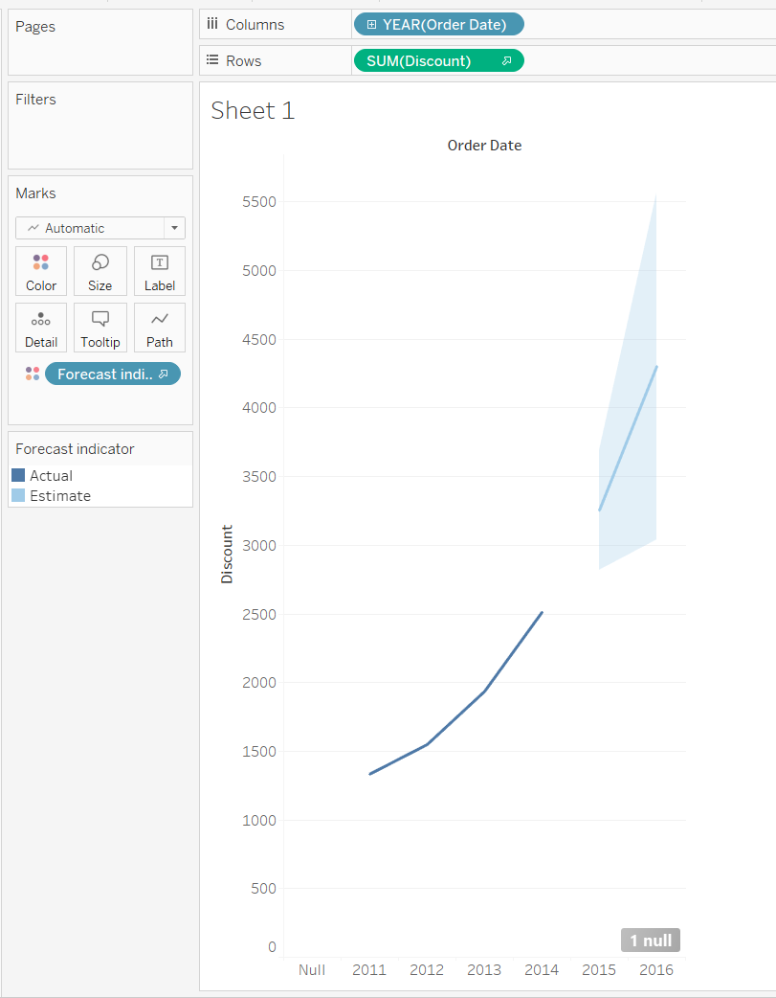

* **Automatic forecasting without seasonality:**

Without seasonality, it shows a straight line; which indicates that the discount will soon become constant. I guess.

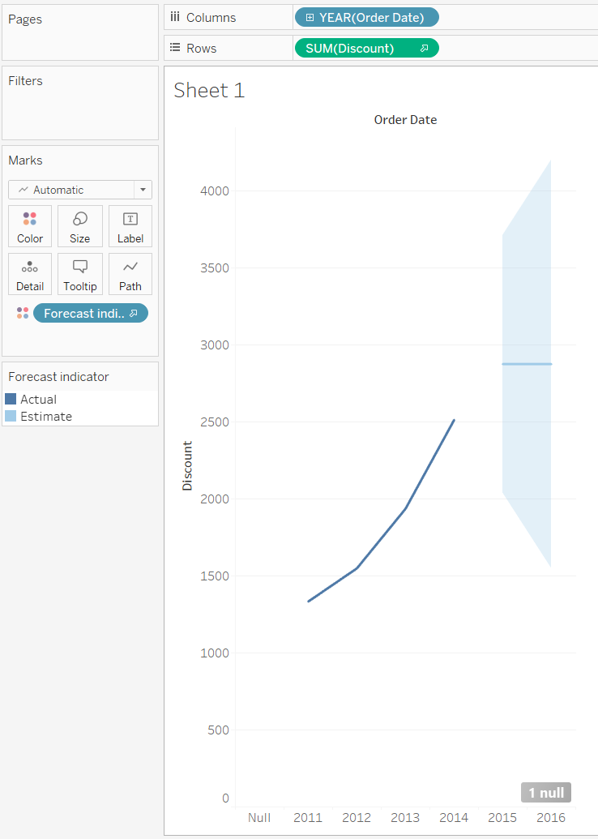

# Additive Trend and Additive Seasonality:

# Additive trend and additive seasonality refer to a time series forecasting model in which both the trend and seasonality components are added to the base data to make predictions. Here, it means that over time, there is a consistent upward trend in the data, and seasonal patterns occur regularly, resulting in increased values at specific time intervals.

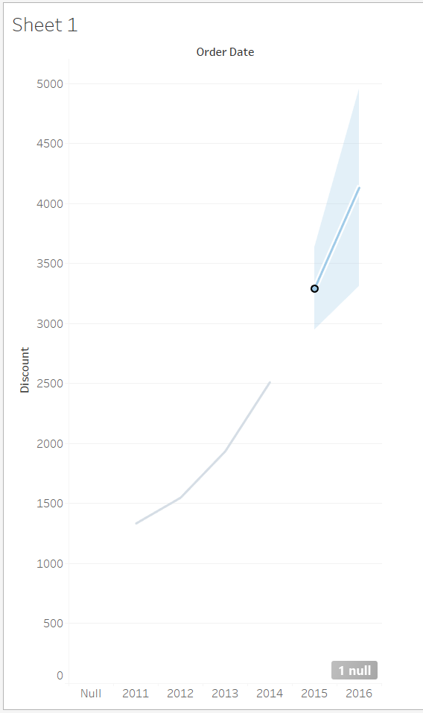

# Additive Trend and Multiplicative Seasonality: In a time series with additive trend and multiplicative seasonality, the trend component is added to the base data, while the seasonal component is multiplied. Here, it implies that the trend contributes a consistent, fixed increase in the data over time, while the seasonality exhibits variations in magnitude relative to the base data, potentially resulting in both larger and smaller seasonal fluctuations.

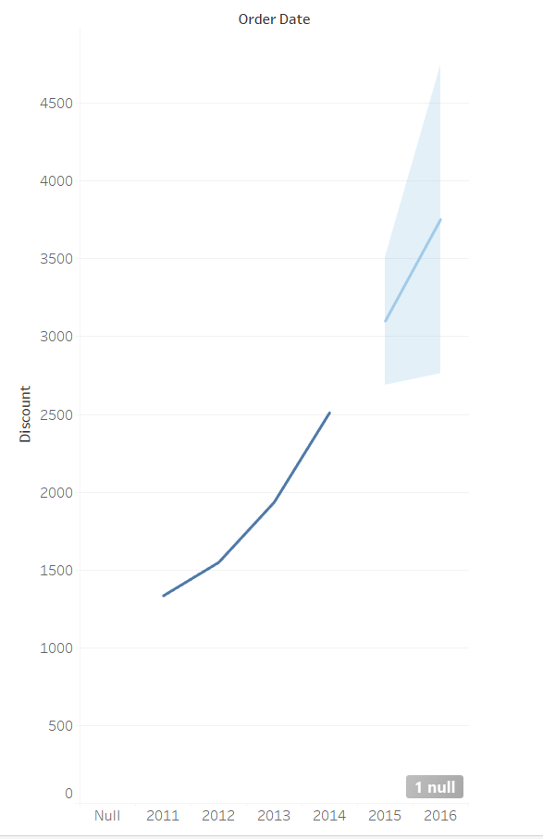

* **Multiplicative Trend and Additive Seasonality:**

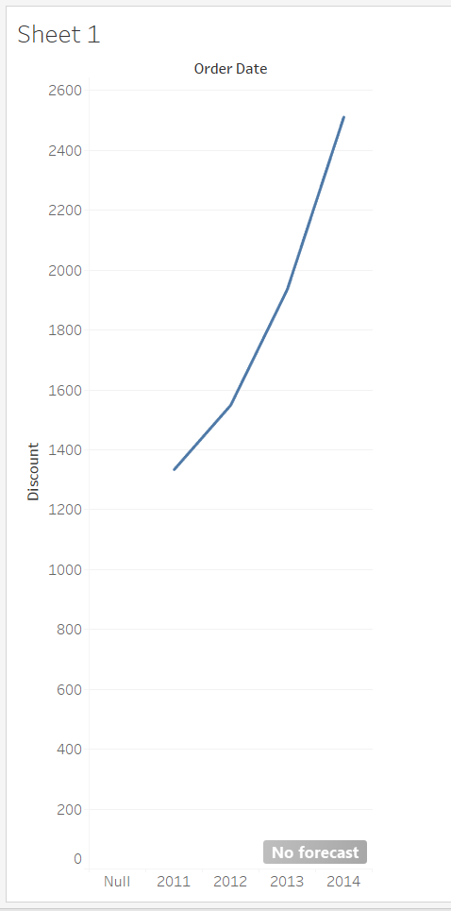

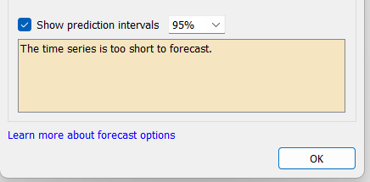

* **Multiplicative Trend and Multiplicative Seasonality:**

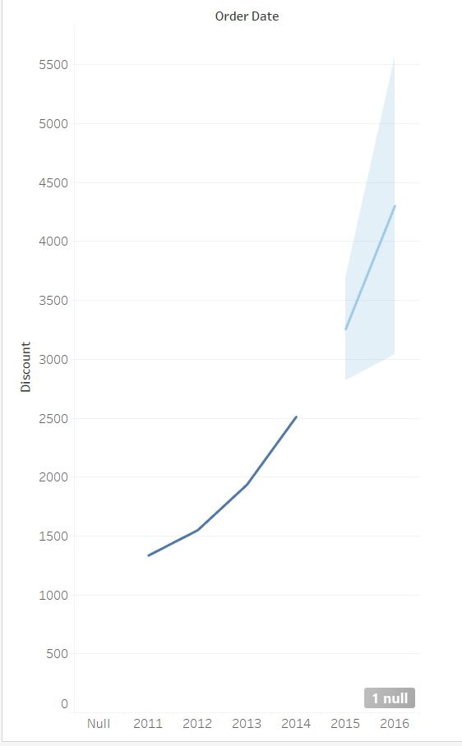

# Conclusion:

I've learned that time series data analysis is a valuable process that involves data acquisition, visualization, trend analysis, and forecasting. Tableau gives many options for visualization of time series data. This makes working with the time series data easier and it also reduces the calculations and is user friendly.

**Date: 26 / 09 / 2023 Signature of faculty in-charge**

# Post Lab Question:

# Compare the additive and multiplicative model of time series.

# The additive and multiplicative models are two approaches to modeling time series data:

# Additive Model:

# Represents a data point as the sum of its components (trend, seasonal).

# Assumes linear relationships between components.

# Suitable for data with consistent seasonal patterns.

# Multiplicative Model:

# Represents a data point as the product of its components.

# Allows non-linear, multiplicative relationships between components.

# Ideal for data with varying seasonal patterns proportional to the overall trend.